Jenkins-Tak02

1) Configure 2 slave machines in jenkins master.

I have installed jenkins in my master with the help of these commands

1. Ensure that your software packages are up to date on your instance by using the following command to perform a quick software update:  
   **[**ec2-user ~]$ sudo yum update –y

2. Add the Jenkins repo using the following command:  
 **[**ec2-user ~]$ sudo wget -O /etc/yum.repos.d/jenkins.repo \

https://pkg.jenkins.io/redhat-stable/jenkins.repo

1. Import a key file from Jenkins-CI to enable installation from the package:  
   **[**ec2-user ~]$ sudo rpm --import https://pkg.jenkins.io/redhat-stable/jenkins.io-2023.key  
   **[**ec2-user ~]$ sudo yum upgrade
2. Install Java (Amazon Linux 2023):  
   **[**ec2-user ~]$ sudo dnf install java-17-amazon-corretto -y
3. Install Jenkins:  
   **[**ec2-user ~]$ sudo yum install jenkins -y
4. Enable the Jenkins service to start at boot:  
   **[**ec2-user ~]$ sudo systemctl enable jenkins
5. Start Jenkins as a service:  
   **[**ec2-user ~]$ sudo systemctl start jenkins

After that i have launched two slave servers and i have installed java and generated a ssh-keygen and copy to authorized_keys and then again in my master node i have copied the pub key to master after creating a directory .ssh with the help of ssh keyscan command and login with admin user and added two nodes in my master so that it will easy to master jenkins you can see below my nodes.

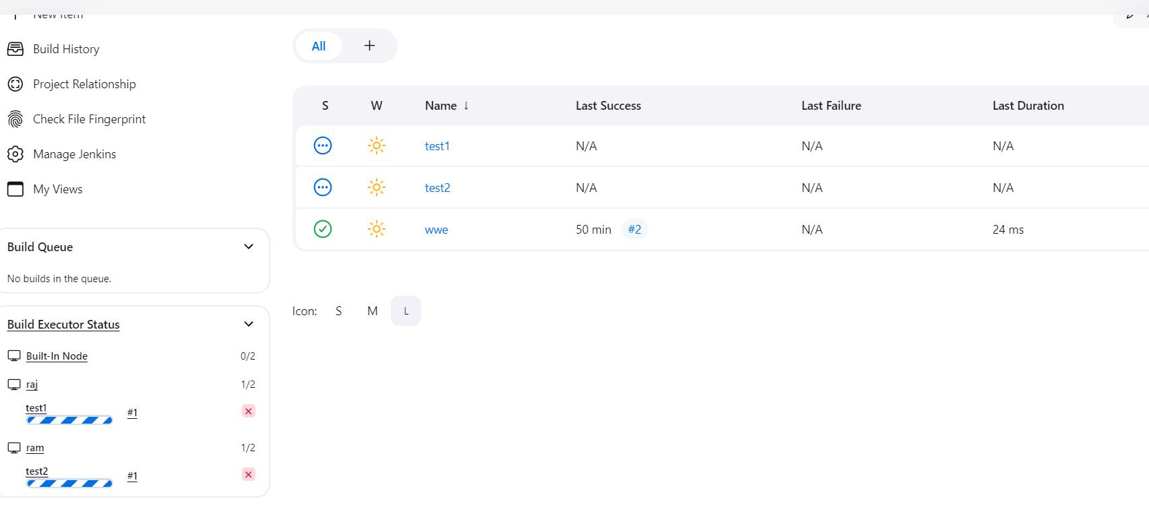

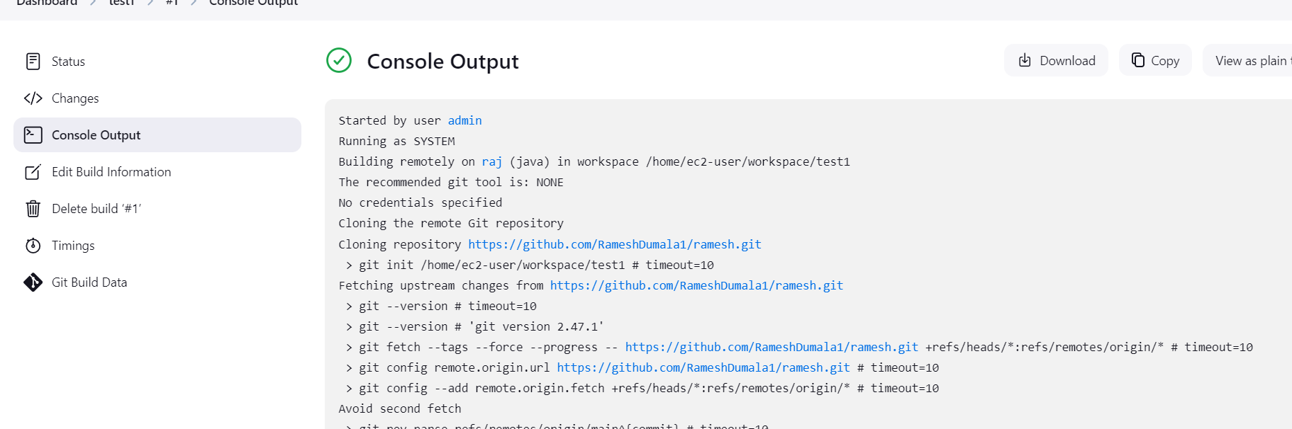

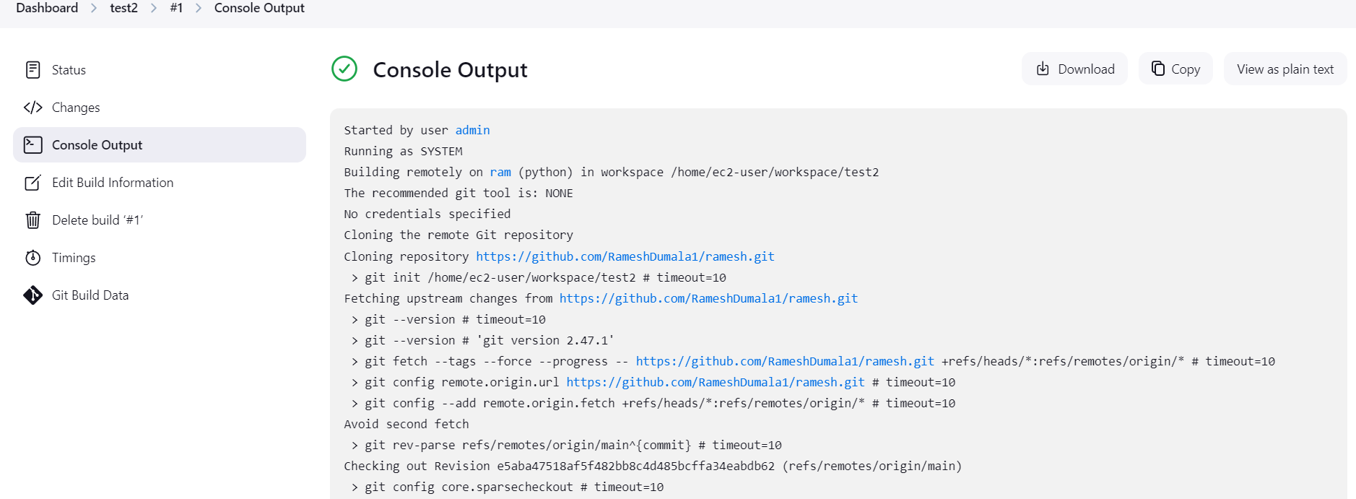

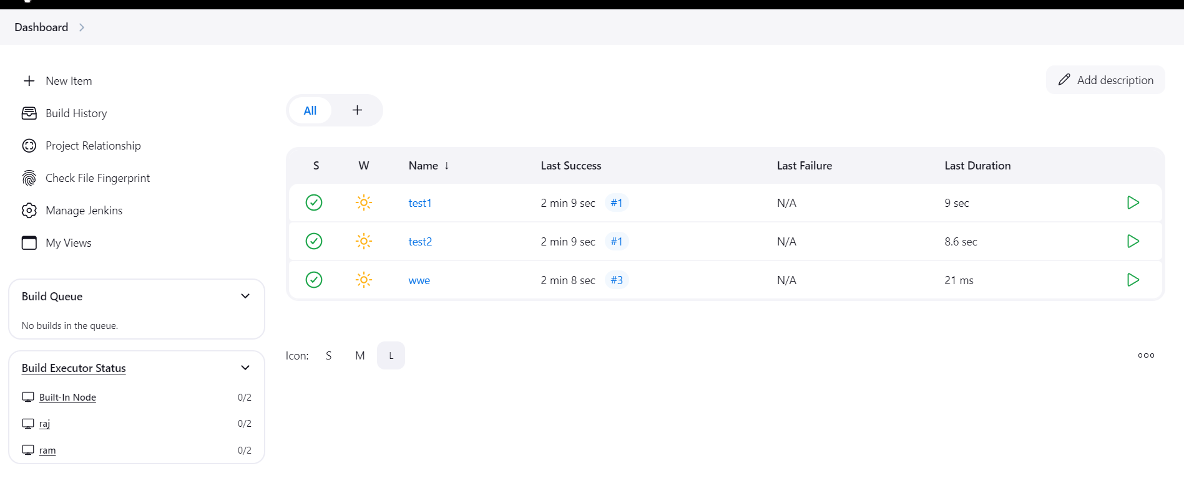

2) Configure webhooks to jenkins job.

In github i have attached my payload jenkins url in webhooks and you can see below

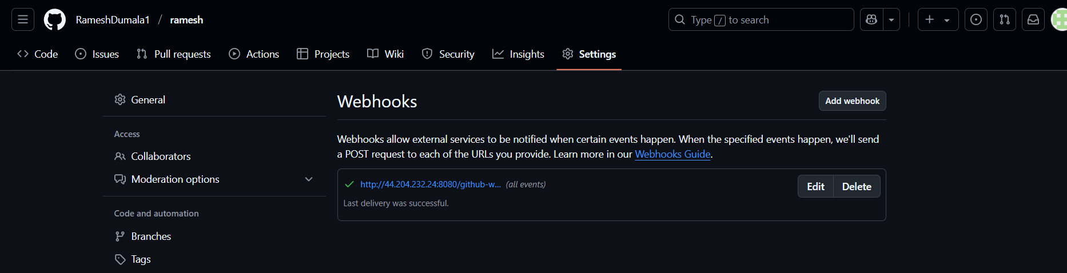

3) Configure poll scm and build periodical options in jenkins job.

I have triggered both poll scm and build periodically in jenkins job you can see below

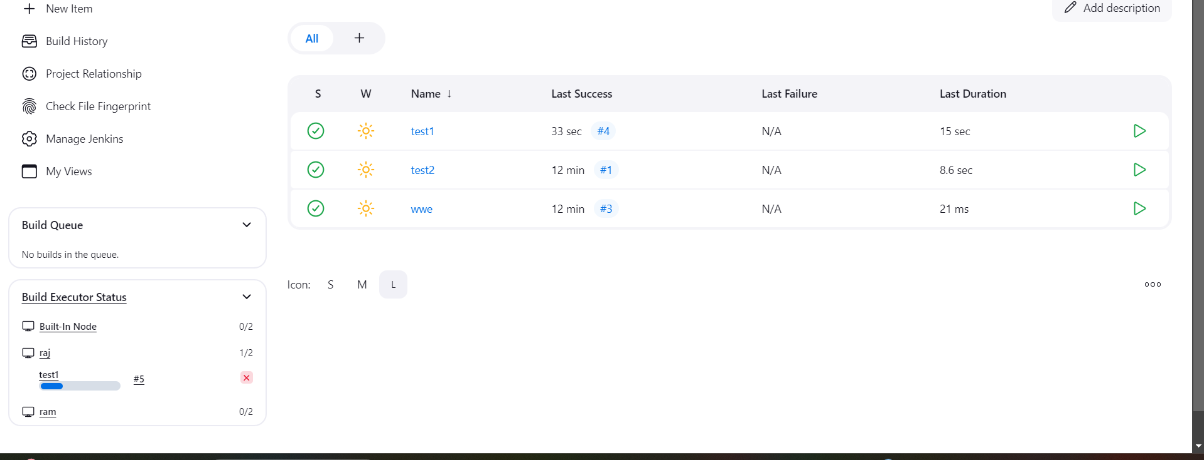

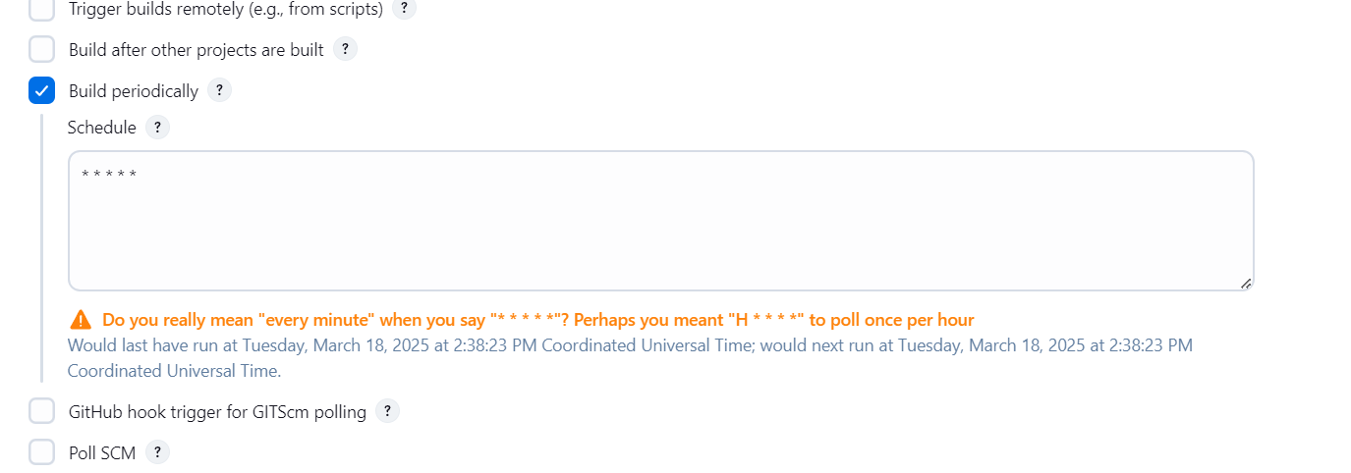

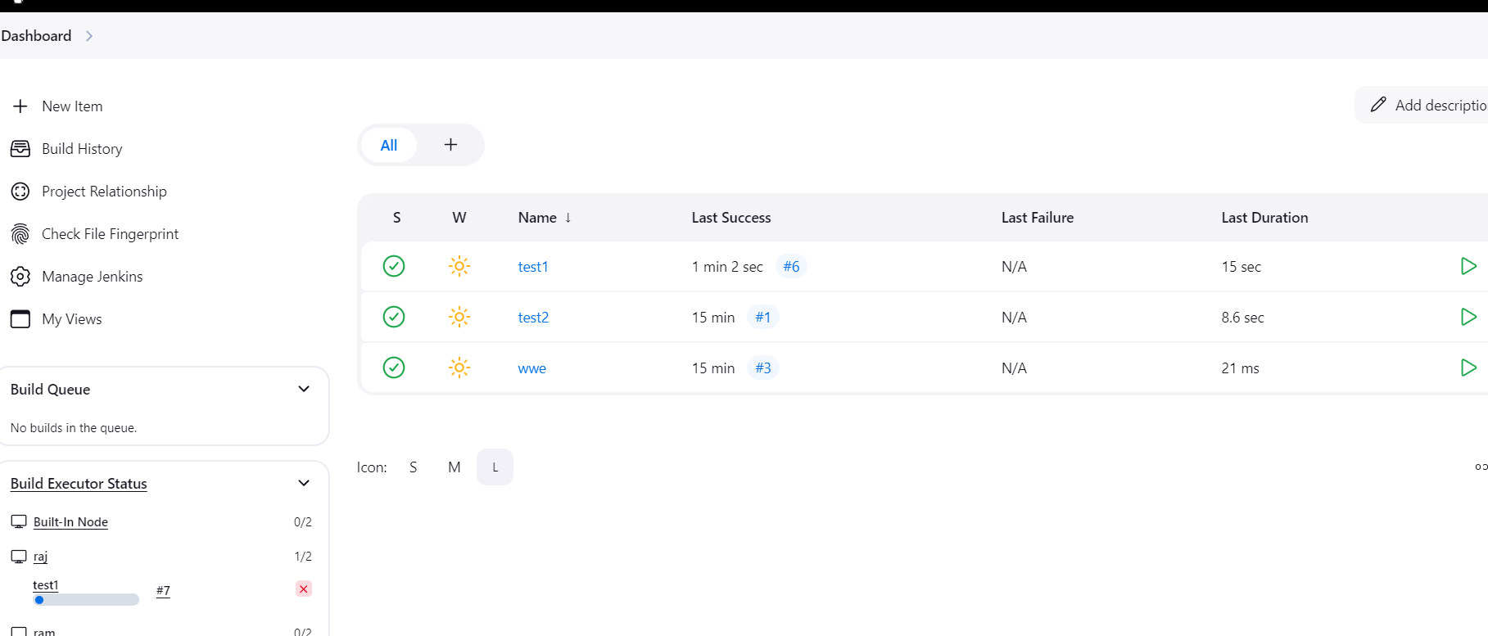

4) Take backup of jenkins server by using bash script.

This is the bash scripting i have written to backup the jenkins directory

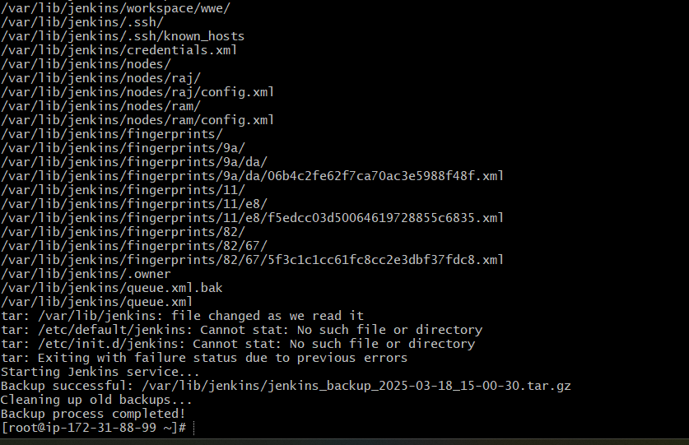

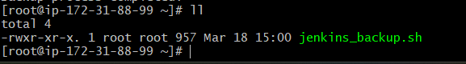

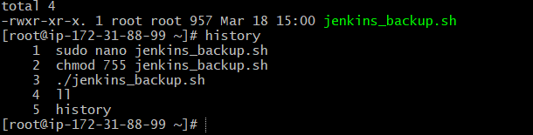

#!/bin/bash

# Define backup directory

BACKUP_DIR="/backup/jenkins"

mkdir -p "$BACKUP_DIR"

# Create a backup filename with a timestamp

TIMESTAMP=$(date +"%Y-%m-%d_%H-%M-%S")

BACKUP_FILE="$BACKUP_DIR/jenkins_backup_$TIMESTAMP.tar.gz"

# Stop Jenkins service before backup

echo "Stopping Jenkins service..."

sudo systemctl stop jenkins

# Backup important Jenkins files

echo "Backing up Jenkins data..."

tar -czvf "$BACKUP_FILE" /var/lib/jenkins /etc/default/jenkins /etc/init.d/jenkins

# Start Jenkins service after backup

echo "Starting Jenkins service..."

sudo systemctl start jenkins

# Verify if the backup was created successfully

if [ -f "$BACKUP_FILE" ]; then

echo "Backup successful: $BACKUP_FILE"

else

echo "Backup failed!"

exit 1

fi

# Remove old backups (keeping only the last 7)

echo "Cleaning up old backups..."

find "$BACKUP_DIR" -type f -name "jenkins_backup_*.tar.gz" -mtime +7 -exec rm {} \;

echo "Backup process completed!"

5) Take backup of jenkins using rethin backup plugin.

By using Thin plugin successfully backup my master jenkins

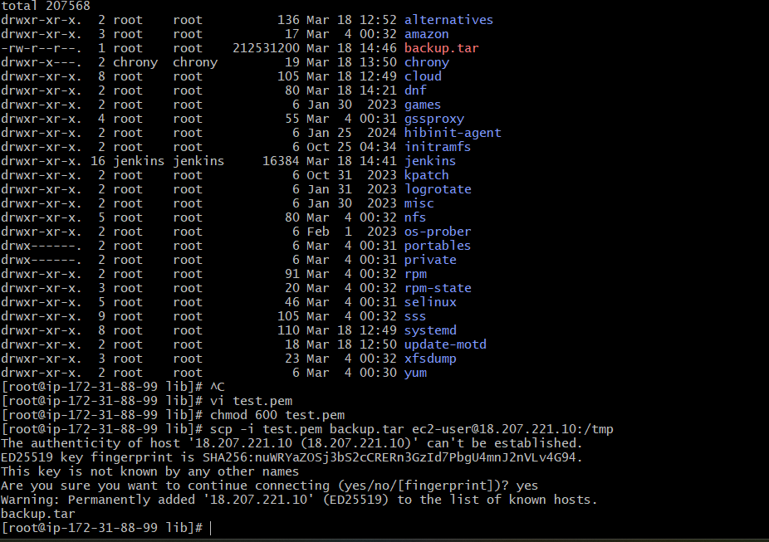

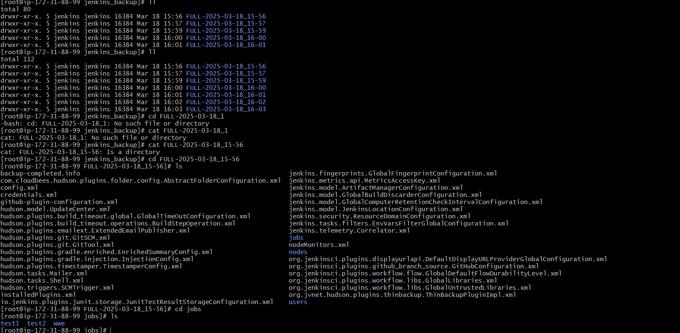

6) Setup a new jenkins server and dump the backup taken in task4.

I have set up a new backup server and by using scp i have send the file to back server and you can see and i forgot restart please make sure restart the server



